

DATA BASE LAB TASK 05

AITZAZ TAHIR CH 19P0012 SIR MUHAMMAD USMAN



**EXERCISE:**

**Task 5.1 Enter and execute the above query and compare your output with that shown in**

**Figure 71.**

SELECT DISTINCT EMP_NUM, EMP_LNAME, EMP_FNAME, PARK_NAME

-> FROM EMPLOYEE NATURAL JOIN HOURS NATURAL JOIN

-> ATTRACTION NATURAL JOIN THEMEPARK

-> WHERE PARK_CODE IN (SELECT THEMEPARK.PARK_CODE FROM

-> THEMEPARK WHERE PARK_NAME LIKE '%Fairy%');

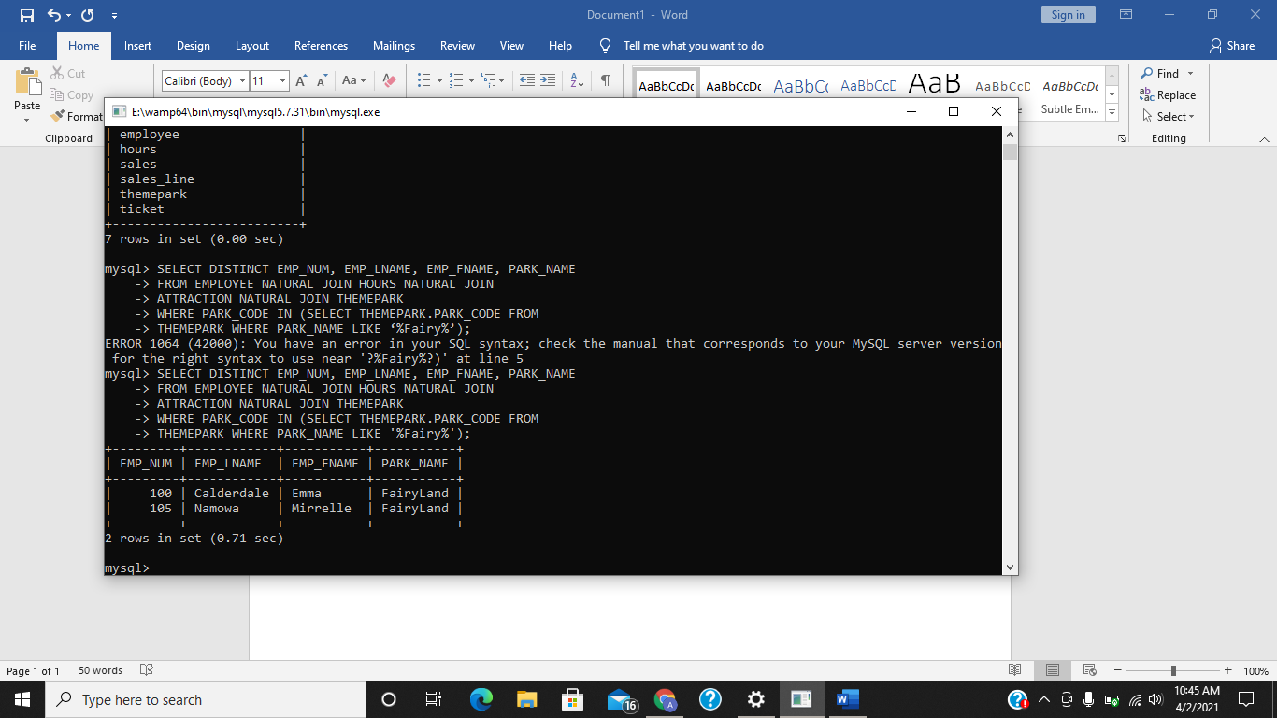

**Task 5.2 Using the query above as a guide, write a new query to display the first and last**

**names of all employees who have worked in total greater that the average number of**

**hours in total during May 2007. Your output should match that shown in Figure 73.**

SELECT DISTINCT EMP_FNAME, EMP_LNAME, SUM(HOURS_PER_ATTRACT) FROM EMPLOYEE NATURAL JOIN HOURS

-> WHERE DATE_WORKED LIKE "2007-05-%" GROUP BY EMP_FNAME, EMP_LNAME, DATE_WORKED

-> HAVING SUM(HOURS_PER_ATTRACT) > (SELECT AVG(HOURS_PER_ATTRACT) FROM HOURS);

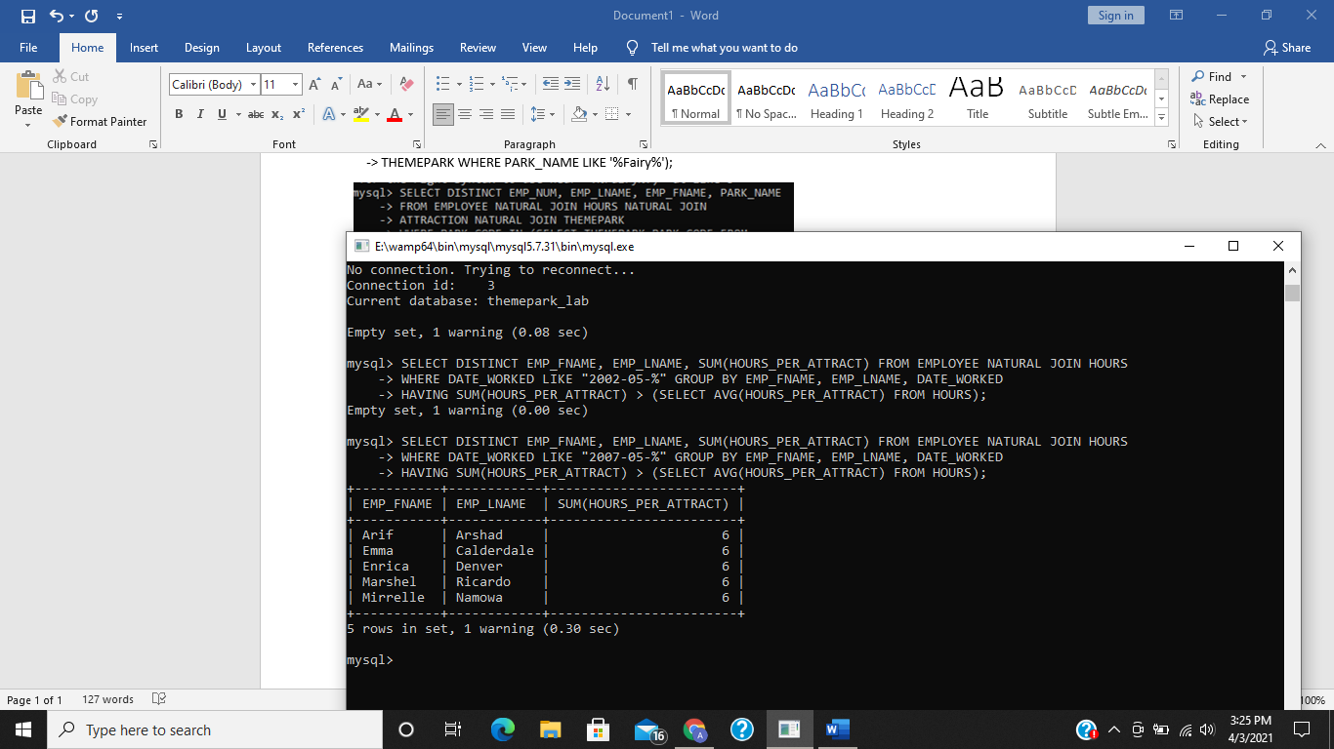

**E 5.1 Write a query that displays the first name, last name of all employees who earn**

**more than the average hourly rate. Do not display duplicate rows.**

SELECT DISTINCT EMP_FNAME, EMP_LNAME FROM EMPLOYEE NATURAL JOIN HOURS

-> WHERE HOUR_RATE > ALL (SELECT AVG(HOUR_RATE) FROM HOURS);

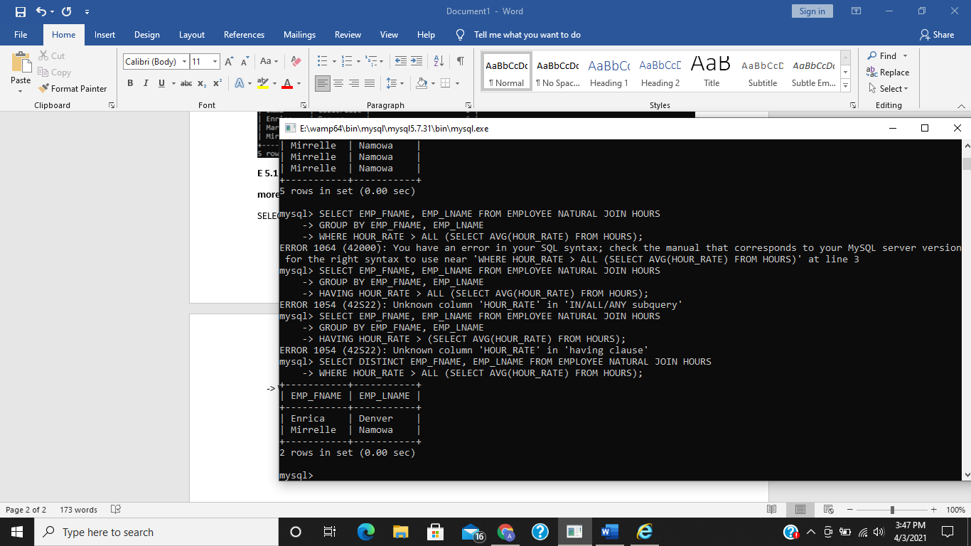

**E.5.2 Write a query to display an employee’s first name, last name and date worked**

**which lists the difference between the number of hours an employee has worked on an**

**attraction and the average hours worked on that attraction. Label this column**

**‘DIFFERENCE’ and the average hours column ‘AVERAGE’.**

SELECT EMP_FNAME, EMP_LNAME, DATE_WORKED, (HOURS_PER_ATTRACT - (SELECT AVG(HOURS_PER_ATTRACT) FROM HOURS)) as DIFFERENCE,

-> (SELECT AVG(HOURS_PER_ATTRACT) FROM HOURS) AS AVERAGE FROM EMPLOYEE NATURAL JOIN HOURS;

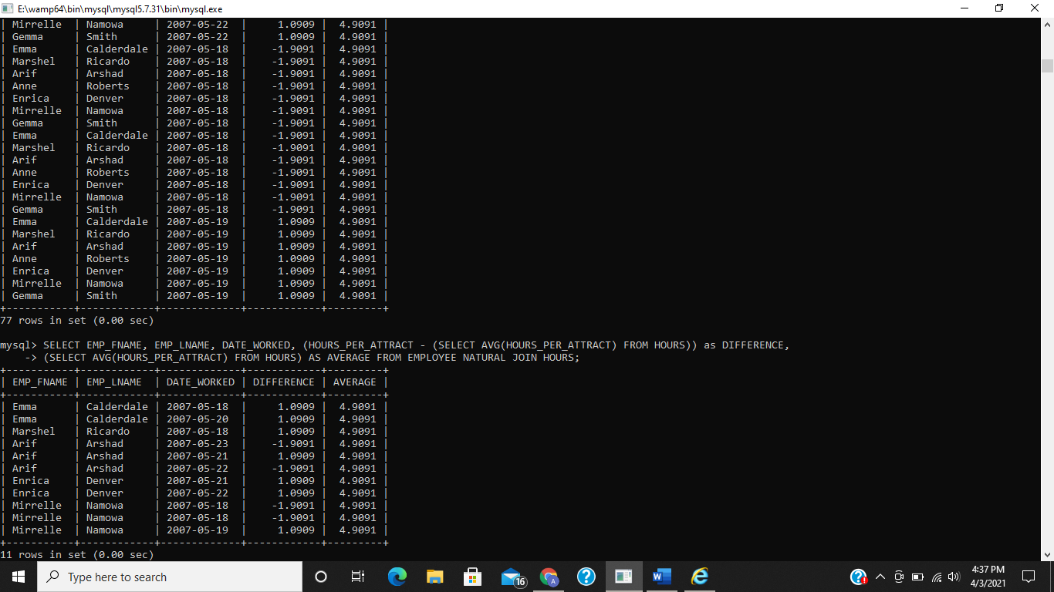

**E 5.3 Type in and execute the two correlated subqueries in section 5.6 and check**

**your output against that shown in figures 76 and 77.**

**QUERY NO 1:**

SELECT TRANSACTION_NO, LINE_NO, LINE_QTY, LINE_PRICE

FROM SALES_LINE SL

WHERE SL.LINE_QTY > (SELECT AVG(LINE_QTY)

FROM SALES_LINE SA

WHERE SA. TRANSACTION_NO = SL. TRANSACTION_NO);

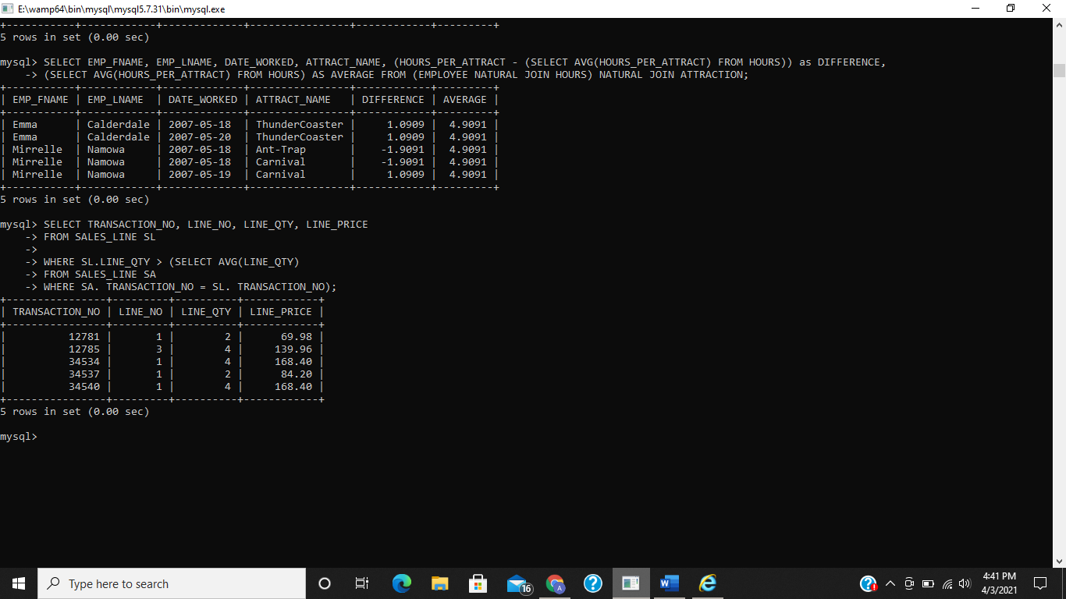

**QUERY NO 2:**

SELECT PARK_CODE, PARK_NAME, PARK_COUNTRY

FROM THEMEPARK

WHERE EXISTS (SELECT PARK_CODE FROM SALES

WHERE SALES.PARK_CODE = THEMEPARK.PARK_CODE);

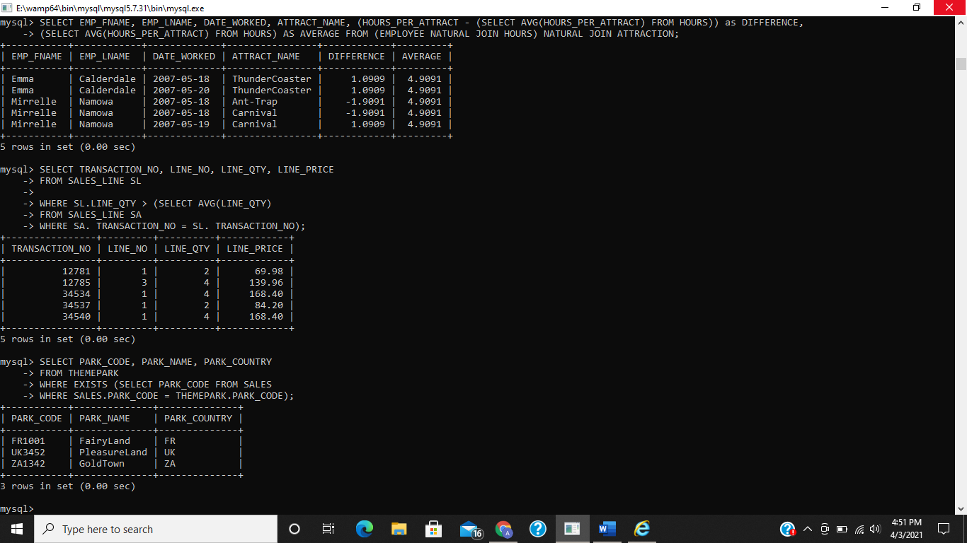

**E 5.4 Modify the second query you entered in E 5.3 to display all the theme parks**

**where there have been no recorded tickets sales recently.**

SELECT PARK_CODE, PARK_NAME, PARK_COUNTRY

-> FROM THEMEPARK

-> WHERE NOT EXISTS (SELECT PARK_CODE FROM SALES

-> WHERE SALES.PARK_CODE = THEMEPARK.PARK_CODE);

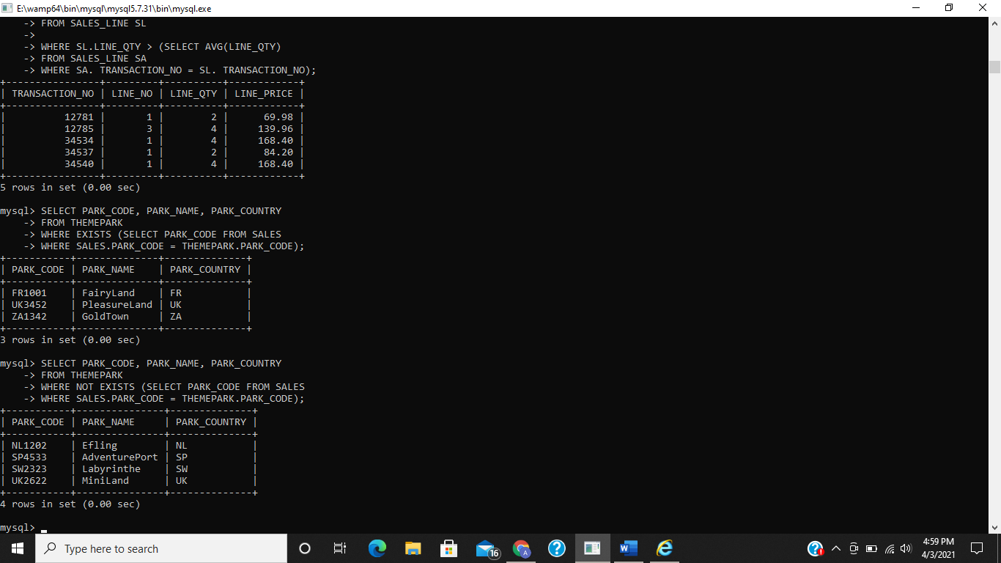

**E 5.5 Write a query to find the attract capacity, with a attract capacity less than or equal**

**to the average attract capacity.**

SELECT ATTRACT_NAME, ATTRACT_CAPACITY FROM ATTRACTION

-> WHERE ATTRACT_CAPACITY < (SELECT AVG(ATTRACT_CAPACITY) FROM ATTRACTION)

-> OR ATTRACT_CAPACITY = (SELECT AVG(ATTRACT_CAPACITY) FROM ATTRACTION);

